LifeCycle bug

User name is left behind when click add

ngOnInit() is the source of the problem

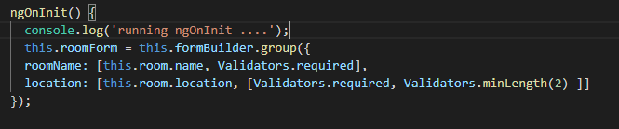

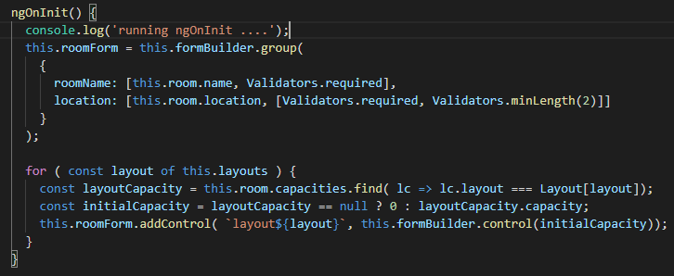

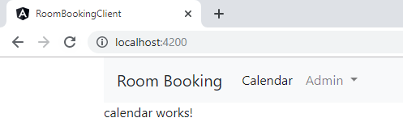

Go into a Room and then Edit a room

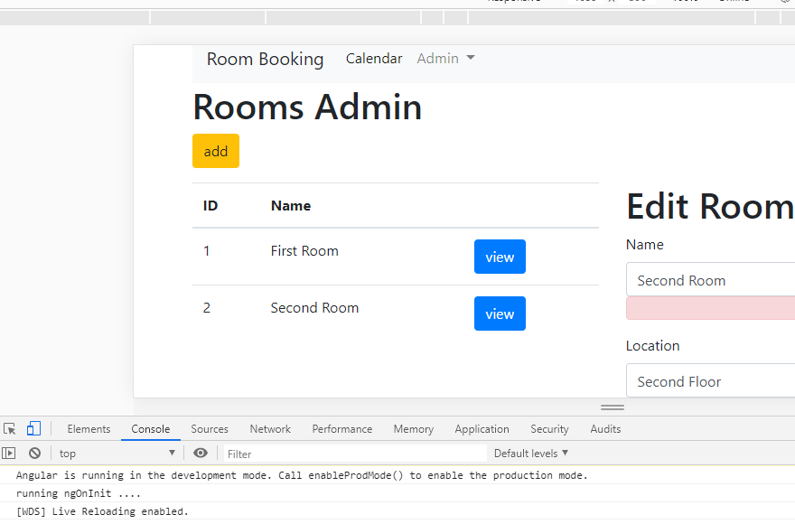

In console appears **running ngOnInit ….**

**If you click on add**

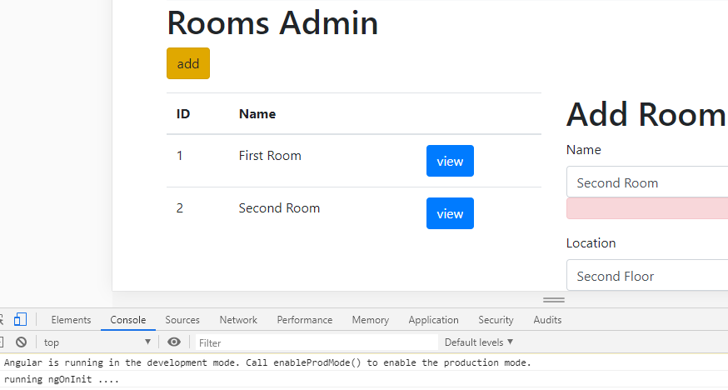

**The console shows ngOnInit does not run again**

**If we go to View >> Edit again the console show the running ngOnInit … a second time**

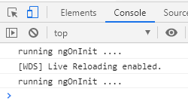

**ReLoading the Edit on Add would solve the issue**

**Or**

**Move the code out of ngOnInit() and into a new method initializeForm()**

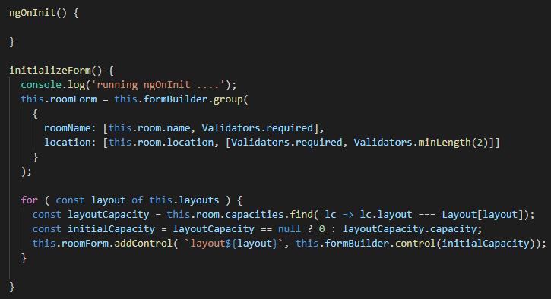

**Now call it from ngOnInit()**

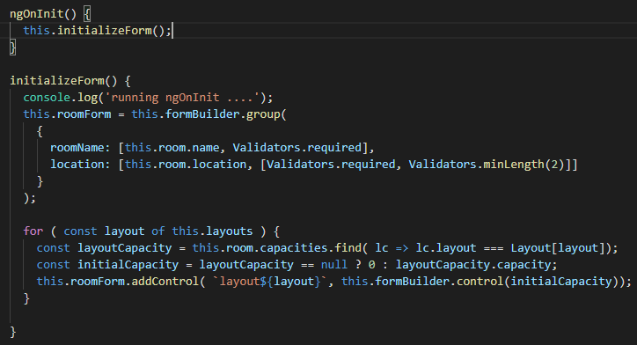

**Child subscribes from the parent**

**Put the event into a service**

**Create the FormResetService**



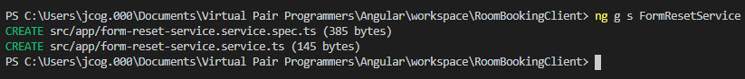

**Now, create an Object of type event emitter**

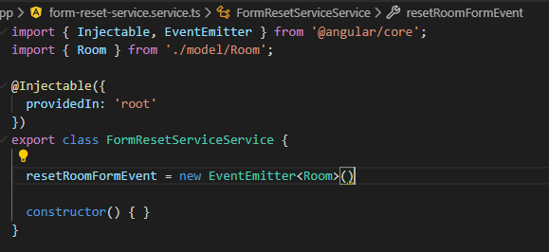

**Rename the file and rename the class**

**This will remove the second Service**

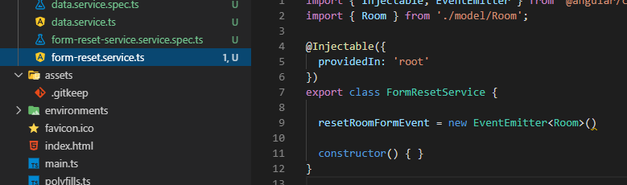

**Fix the spec file as well**

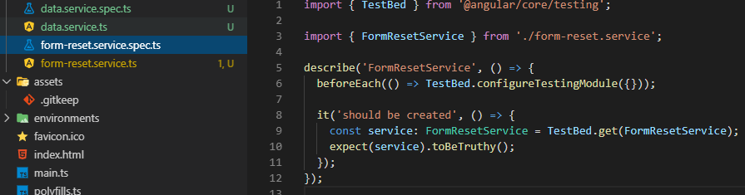

**Now, we need to reference the Service in 2 places or share it (Services are shared)**

**Inject the FormRestService into the RoomsComponent file**

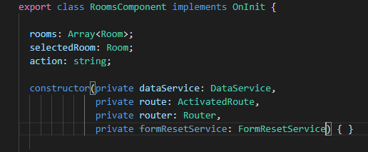

**Emit the event**

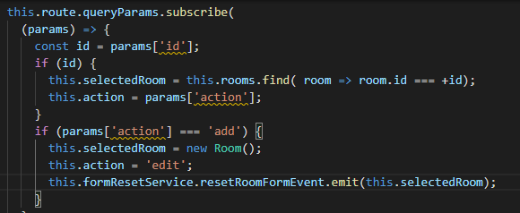

**Subscribe to the event in the RoomsEditComponent**

**First add a reference to the service**

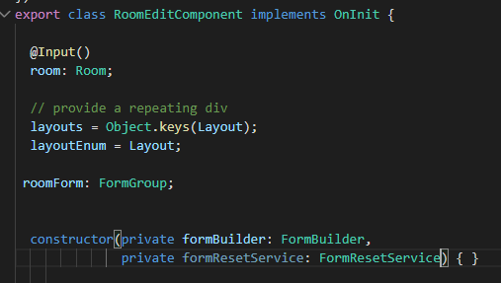

**Now, update the ngOnInit() to subscribe to the event**

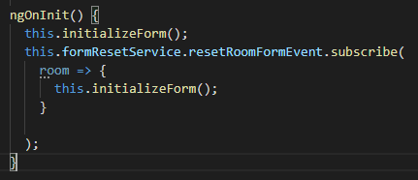

**Should add the this.room reference as well**

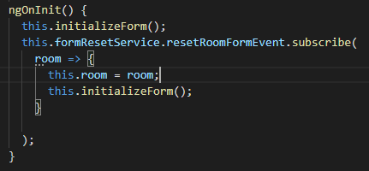

**Cleanup with the subscription method**



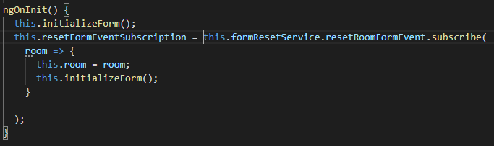

**Unsubscribe with OnDestroy**

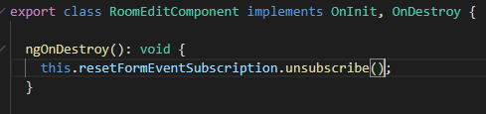

**Test it**

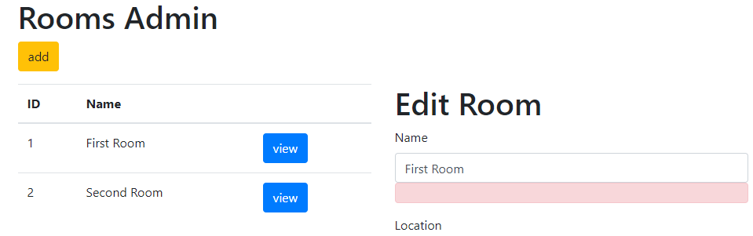

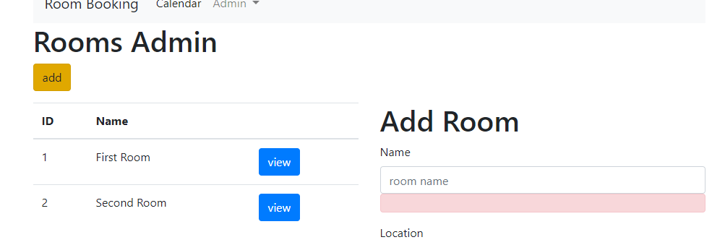

**The name of the Room resets!! Great**

**Now, let us do this for Users:**

**In the FormResetService create the one for User along with the Room**

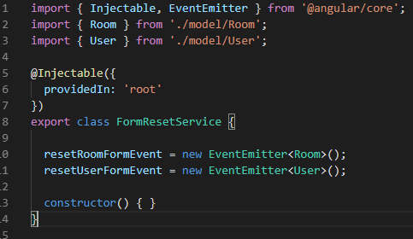

**UserComponent file**

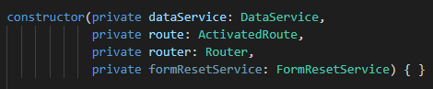

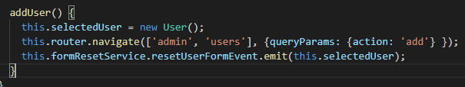

**UserEditComponent file**

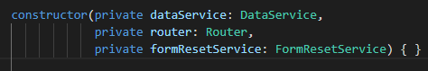



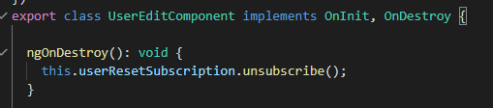

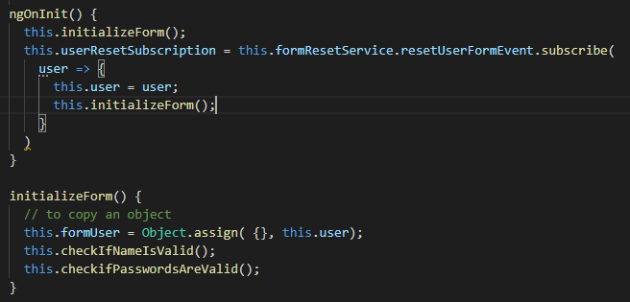

**Test Users**

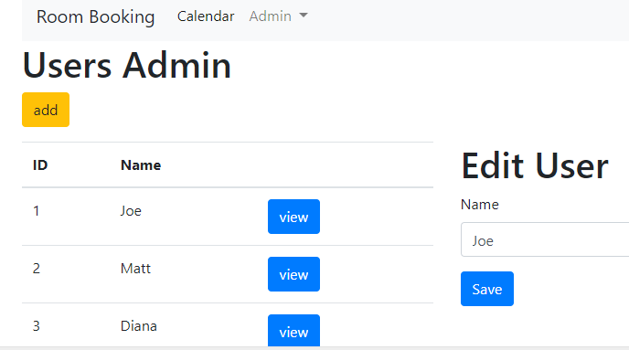

Fix Error: Solution end of video on User lifecycle bug

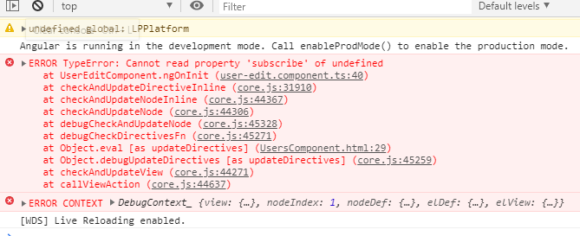

**Save the Service: Fixed Error**

